#### Q. What kind of applications you have tested? TYPES OF APPLICATIONS:

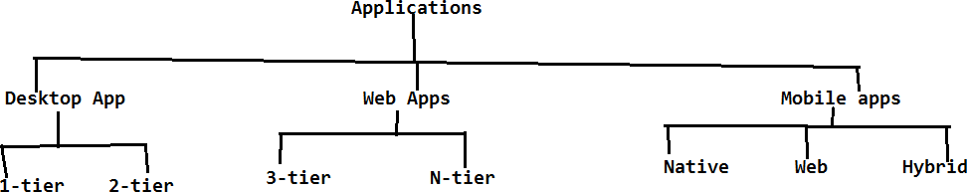

There are three types of applications which can be tested;

1. Web Applications
2. Desktop Applications
3. Mobile Applications
   1. **WEB APPLICATIONS:**

These applications are accessed with the help of some browser. It is oftwo types

* + 1. 3-Tier architecture applications.
    2. N-Tier architecture applications.

**Environment/System**:

All the applications are combination of the environment. Environment contains:

* + - 1. Presentation layer. HTML, CSS, JS, React JS….
      2. Business layer. Java, Python, C#.....
      3. Database layer. Mongo DB, Oracle, SQL Postgres….

UI

BAckend

Database

**ENVIRONMENT**

PRESENTATION/CLIENT LAYER

APPLICATION

Request Response

DATA BASE

SERVER

BUSINESS LAYER **Java, Python, C#, C++…**

Request Response

DATABASE LAYER

UI – Python – Database = Application

##### Presentation layer:

The Front end which the end user is going to access is known as presentation layer/client.

##### Business layer:

It is the server which is responsible to serve the request. It means it will take the request from the application, send it to the database, takes the response from the data base and send it back to the application. The whole process is known as serving the request.

Ex: Tomacat, JBoss, Weblogic, WebSphere, IIS

##### Database layer:

Database layer is responsible to store the data in the form of tables. Ex: MS SQL, My SQL, ORACLE

Environment -

**Local** - Our Computer scope is up to their functionality D1, D2, D3...

**DEV**, - Central Repository (D1+D2+D3 code like Login, Homepage, Logout to see application)

- we can access application where UI - Python - DB 100

- Build is a process to convert source code to .exe file they can test UI

**QA**, - Environment that is for testers us He will QA environment fine US

**UAT**, User Acceptance URL will change

**PPT**, - Preproduction Test

**PRD** - Production - to see our application live

1. **3-Tier architecture applications:**

In 3-tier architecture applications, the above 3 Layers are available in three different machines (Layers) which we will call it as tiers. Hence they are called as 3 Tier architecture applications.

Ex: PL - Browser SErver - Tomacat DataBase - Oracle

1. **N**-**Tier architecture applications:**

It is same as like 3-tier architecture applications based on the number of users (load), we will be having more number of servers and databases.

Based on the load request the business logic will be distributed among the servers and DB’s. Hence we will call it asDistributed environment applications.

PL

Server

DB

PL

Server

DB

PL

Server

DB

BL

DBL

* 1. **DESKTOP APPLICATIONS:**

These applications can be accessed without any browser.

Ex: Skype, calculator, MS Office, vlc player etc.

It is of two types:

* 1-Tier
* 2-Tier
* **1-Tier:**

These applications are limited to a specific system (PC). All the 3 layers PL, BL and DBL will be available in that specific system only.

Ex: VLC player , Calc

* **2-Tier:**

The presentation layer will be available in one system the business layer and Data base layer will be available in another system, with the help of LAN/WANwe can able to access these applications from multiple systems. Hence we will call it as 2- Tier applications it is also known as client- server architecture applications.

Ex: Skype

NOTE:For Desktop Applications we need to install application at user/client side then only we arcane able to access it. To perform testing for desktop applications we need to perform it in both client as well as server.

For Web application, we need to test it in client only.

(BL)

Server + DBL App

WAN

LAN

LAN

PL

M1

M2

M3

* 1. **MOBILE APPLICATIONS:**

The applications which can be accessed on the mobile platform are known as Mobile Applications.

Ex: Android, IOS, Blackberry, Windows etc.

They are of three types

1. Native Applications
2. Web Applications
3. Hybrid Applications
   1. **Native Applications: Without browser**

These applications can be accessed without any browser. Ex: Viber, call functionality, msg, clock etc.

* 1. **Web Applications**: With browser acesss

These applications can be accessed with the help of the browser in the mobile. Ex: selenium4testing.com

* 1. **Hybrid Applications**: Apps

These Applications can be accessed both without browser and with browsers. Ex: Gmail/Gmail app, Facebook/Facebook app, Banking Websites/App etc.

NOTE:ForWeb Applications not necessary to install application at user/client side as we are able to access with the help of browser. To perform testing for web applications we need to perform it only in client.

Applications & Environments

help of internet - web applications

Intranet - within orgnisation network

Internet - all over world

https://www.URL of app Credentials for that

Desktop application - where it requies either internet or not

Mobile application - apps, access different browsers

UI -Java/Python - DB = Application

Environments: Winter, Summer , Rainy

LOC - D1 K, D2 V, D3 Se on different modules

- Login, Homepage, Search

Central Repository i.e. GIT/BitBucket

K branch, V branch, Se branch

Pull request to merge Development branch

clone development branch into their local system

DEV - Development code (D1+D2+D3) atleast application url redirecting to , login logout.

- Build process of converting the source code into .exe file / tar file/ war file

- application will be accessible within the dev environment

QA/ Staging/ Testing - gmail application STLC test cases, test execution, defect

UAT - alpha within client side team, beta testing end user side/ client side

PPT - Pre Production Test / Infrastructure behaviour load test, stress test sales

- Load runner, Jmeter

PRD - Production